Form-A-II (EPI)

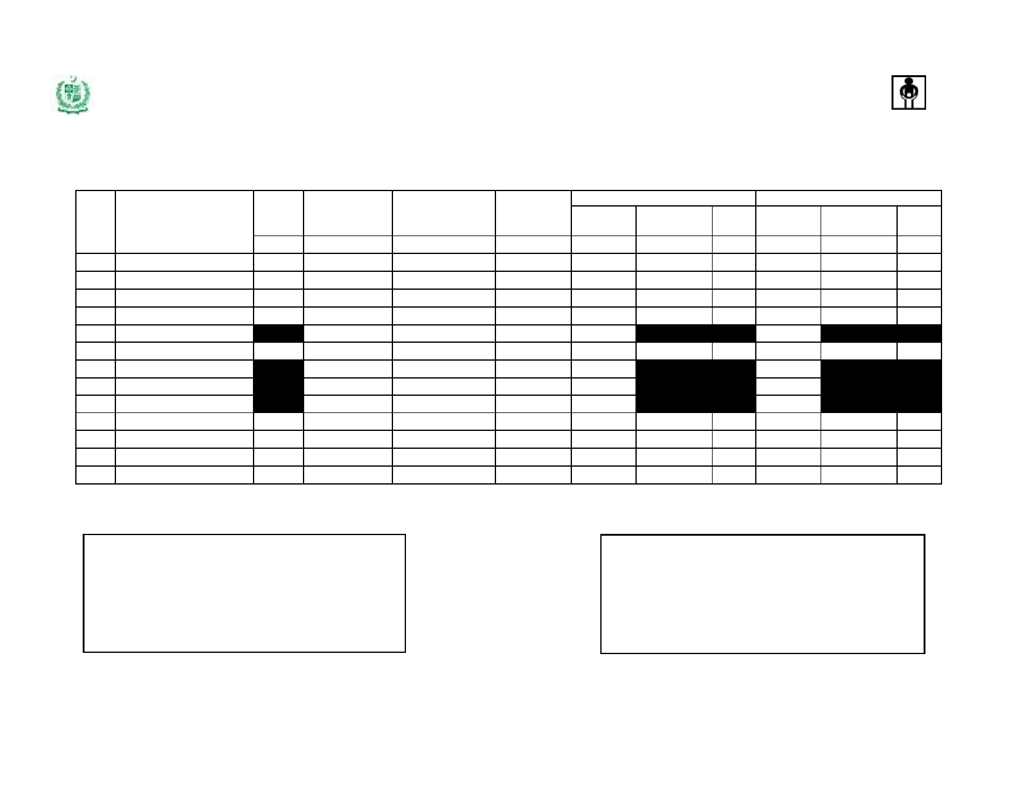

***Expanded Program on Immunization, Government of Pakistan***

**Stock Issue & Receipt Voucher**

(To be filled by District/Tehsil/Taluka Stores)

**Campaigns Type (**  **)**

**Supply from (District/Tehsil/Taluka):**________________________ **Issued To (Tehsil/Taluka/UC):** ________________________ **Date:** __________________

**Products**

**Doses**

**per**

**Manufacturer**

**Batch #**

**Expiry Date**

**Issue Quantity**

**Total Doses**

**VVM**

**Receive Quantity**

**Total Doses**

**VVM**

**S.No**

12

3

456789

mOPV1

bOPV tOPV

Measles

DIL Measles

TT

AD Syringes 0.5 ml

Recon. Syringes (5 ml)

Safety Boxes

**vial**

**A**

20 20 20

01

10

**B**

**C**

**(MM/YY)**

**D**

**Vials/Nos.**

**E**

**(F = A x E)**

**F**

**Stage**

**G**

**Vials/Nos.**

**H**

**(I = A x H)**

**I**

**Stage**

**J**

17

18 19 20

Note: Use blank rows, if needed to add more than one batch received for one product/new products

**Issued by** -

Name & Designation:___________________________________

Store Name: __________________________________________

Signature & Date:______________________________________

**Received by** -

Name & Designation:___________________________________

Store Name: __________________________________________

Signature & Date:______________________________________